In collaboration with multiple partners, Rainmatter initiated a Sandbox initiative in Odisha to actionise the Place thesis, starting 2023

About Kendrapara
With a population of ~15 lacs across 9 blocks and ~1600 villages, Kendrapara is a Coastal delta district located between the Brahmani, Baitarani, and Mahanadi rivers, home to the Bhitarkanika mangrove ecosystem and highly vulnerable to cyclones and saline floods. Predominantly agrarian, with paddy, pulses, and fisheries it is also largely rural and informal, with significant job linked migration. Facing mangrove loss, saline intrusion, and human–wildlife conflict, especially around crocodile zones, Kendrapara has been a focus district for the government (Rich political past / Biju Patnaik’s constituency) in Odisha’s coastal resilience programmes, emphasizing pond rejuvenation, mangrove restoration, and women-led adaptation.

In view of these characteristics, the objective of the Sandbox initiative was to evaluate the potential of Kendrapara emerging as a model for ecosystem-based rural resilience, blending conservation, livelihoods, and community leadership.

Introduction
Spread across 205 villages, The Sandbox in Kendrapara represents an example of how systemic, place-based interventions can build climate resilience and local ownership through community action, partnerships, and adaptive governance.

Identifying the Problems
The first step in the Kendrapara sandbox was deep sensemaking—listening to the land and people before defining interventions. While we have multiple frameworks for this “Ownership” discovery, Goonj’s Gram Swabhimaan approach was deployed in a DIY format with the process handed over to community representatives who suitably contextualized it for Kendrapara.

Observed Challenges:
- Ecological Degradation: Repeated cyclones, saline intrusion, and erosion
- Livelihood Insecurity: Traditional agriculture and fishing were becoming unsustainable, forcing seasonal & distress migration (Kendrapara is the “Plumber” capital of India, now even exporting plumbers to the Middle-east)
- Cultural Disconnection: Mangroves and water bodies, once integral to local identity, were now viewed as threats
- Institutional Fragmentation: Multiple schemes existed but with limited local convergence and ownership

These patterns surfaced through participatory mapping, citizen juries, and informal dialogues led by local organizations and facilitated by the sandbox team shifting the focus from 'What is wrong here?' to 'What is happening here, really?'

Community Ownership: People as Architects of Change
Ownership emerged when local actors began leading problem-solving, not merely participating in projects.

- Women Climate Champions: Over 300 women across Odisha, including 100 in Kendrapara, were trained as Climate Champions under the ECRICC programme (UNDP, Mar 2025). They adopted resilient farming, led mangrove replantation, and shared knowledge through peer networks
- Self-Help Groups and Youth Networks: SHGs, youth clubs, and panchayat representatives formed the nucleus of action. They engaged in Citizen Juries, Climate Recipe exhibitions, and Gram Swabhiman dialogues—turning abstract consultations into tangible community voice mechanisms
- Cultural Re-framing: The narrative around mangroves shifted from fear to friendship. Community members began to see mangroves not as obstacles but as natural allies—providing flood protection, honey, crab farming etc
- Local Institution Building: Nature’s Club, a Kendrapara-based NGO, evolved into the core local institution—holding the space for external collaborations while ensuring the ecosystem remained locally governed

Key Actors and Orchestrators
- Grassroots Stewards: Women Climate Champions and village youth led coastal agriculture reforms, mangrove restoration, and awareness drives
- Civil Society Partners: Nature’s Club, WellLabs, Socratus Foundation, Goonj
- Government and Global Partners: Odisha Forest & Environment Department, UNDP, GCF, Kendrapara District Administration
- Media and Cultural Amplifiers: Local influencers and journalists produced short films and reels during the Mangrove Patha Utsav 2024

In terms of progress on ground, in the past 2 years
- Agarbatti Producer Groups - 3 Producer groups (PG) comprising over 150 women have been formed to produce Organic Agarbatti, being sold to corporates like ITC (Ref. annexure for image of Kanika PG)
- SRI cultivation - Saline resistant rice varieties introduced in 84 villages adopted by 7000+ farmers
- Nalia artisan group - 1000 families across 5 villages formed making handicrafts using the Nalia grass
- Waste to wealth tailoring - 7 tailoring clubs of 150 women
- Azolla cultivation - 5000 growers across 120 villages to provide animal feed and also as a bio fertilizer
- Mushroom cultivation - 45 Self Help Groups trained on mushroom cultivation. This also enables paddy stubble reuse as paddy stubble is used as the growing medium for mushrooms
- Organic pesticides & fertilizer production - by over 5000 families

Lessons and Takeaways
- Start with Listening: Real insight comes from community sensemaking
- Shift the Story: Changing local narratives builds intrinsic motivation
- Identifying Anchors : Facilitation models like Nature’s Club ensure continuity
- Design for Emergence: Iterative prototypes enabled adaptive scaling.
- Institutional Integration: Bottom-up innovation influenced formal systems.

Conclusion
The Kendrapara sandbox evolved through iterative community-led experimentation—mapping, co-designing, celebrating, and transferring ownership—transforming fragmented efforts into a scalable, locally sustained climate resilience model.

Mentions in Public Sources (2024–25)
- https://www.newindianexpress.com/good-news/2025/Jul/06/eco-champions-empower-village-communities-for-sustainable-livelihood
- https://www.adaptation-undp.org/women-who-tamed-tides-meet-climate-champions-odisha
- https://www.orissapost.com/mangrove-patha-utsav-collaborative-efforts-key-to-save-coastal-ecosystems/
- https://www.thehansindia.com/andhra-pradesh/centre-to-curb-migration-launched-994010

Pictures

Kanika Agarbatti Producers group
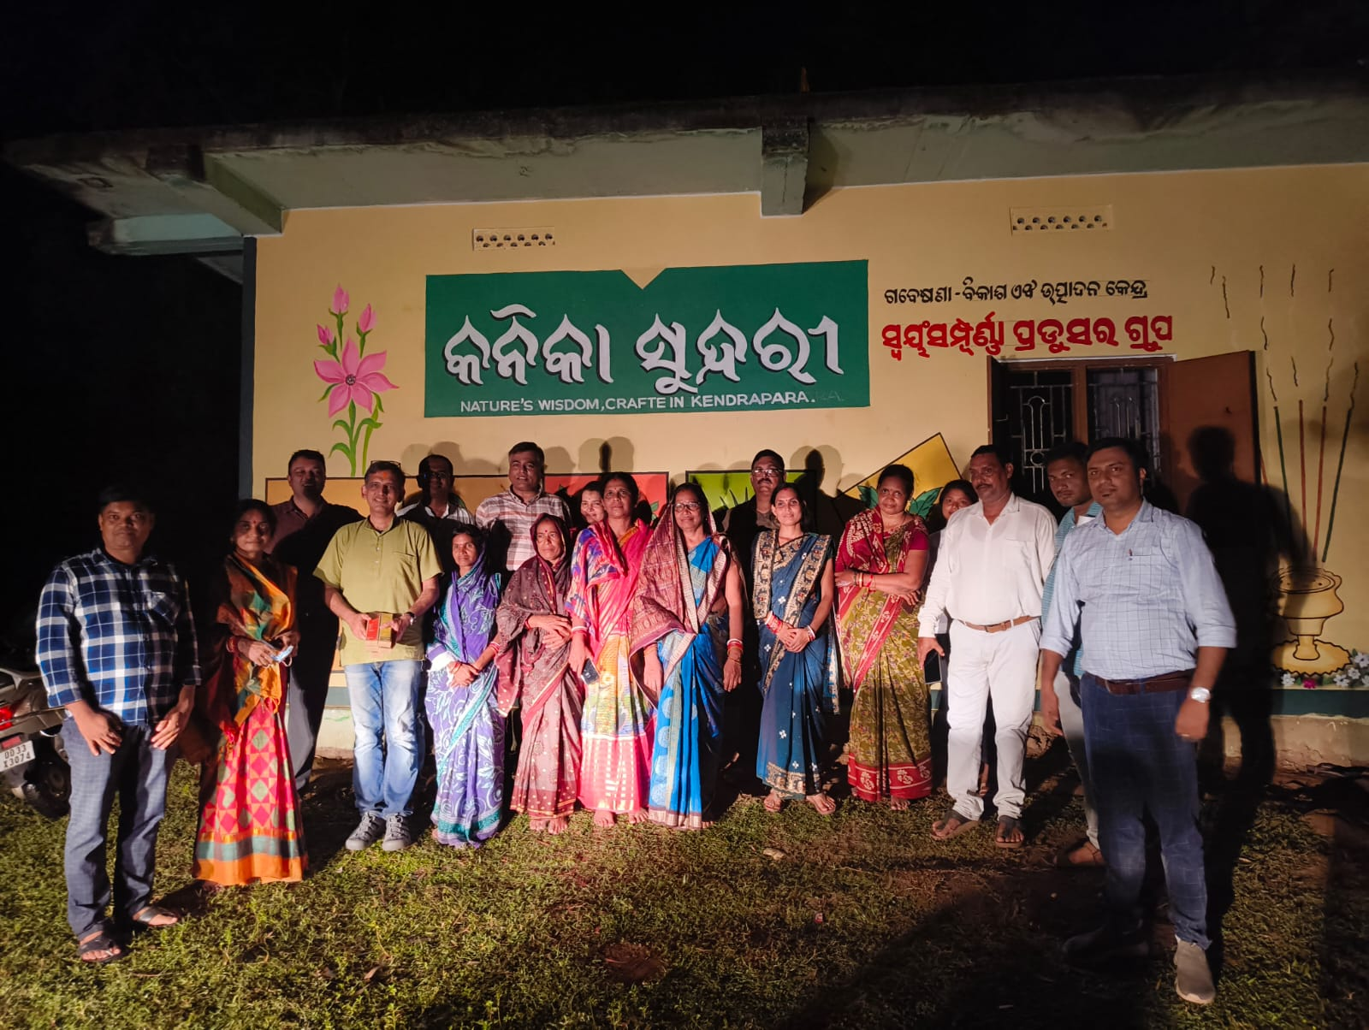

Bhitarkarnika National Park
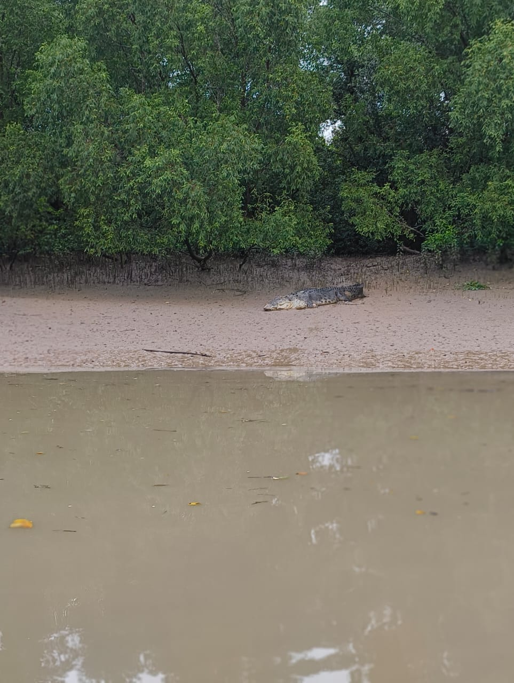

Mangrove forests, Bhitarkarnika national park
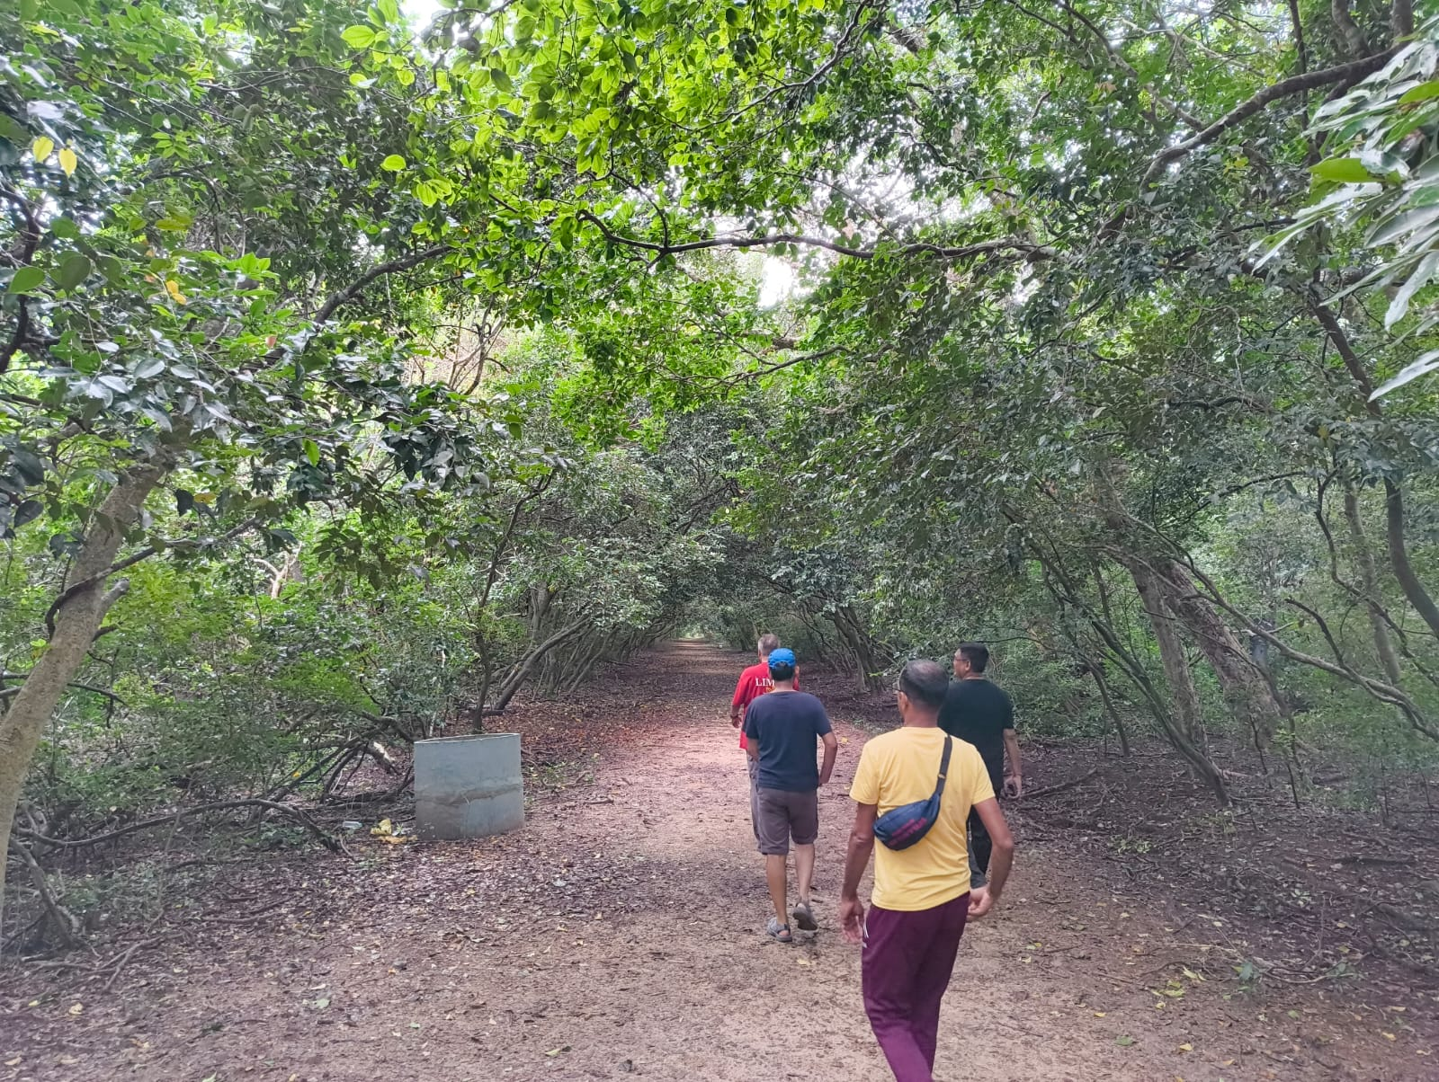

Naliya produce group, Baghataila
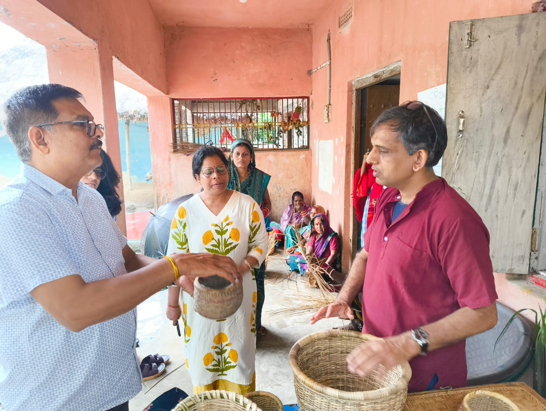

Saline Resistant Rice (SRI) farmers group
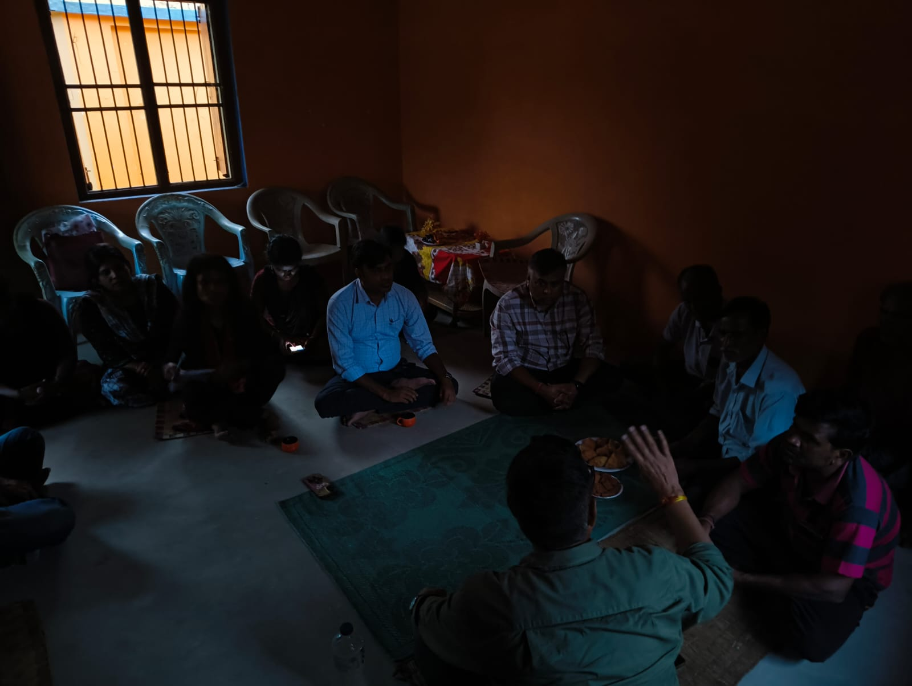

Village resource center, Ramnagar
